**Jarette’s Farm Journal**

**Jarette Hurry**

**October 2020**

A ryegrass infestation can reduce wheat yield by up to 75%. Ryegrass can be a tremendous yield robber and the contamination from ryegrass seed can create additional income loss due to dockage at the point of sale.

For effective ryegrass control, always start clean. Scout very closely before deciding not to use a burndown. If a burndown is warranted, use a material like Gramoxone or Roundup to better guarantee a good ryegrass kill. Use high quality seed, plant on time, and make sure to apply some fall nitrogen to help create a healthy, competitive wheat crop. Create a seed bed that allows all seed to be planted at a correct depth, thereby allowing all seed the opportunity to germinate quickly and uniformly.

**Preemergence Herbicides for Ryegrass**

*(My recommendation is Zidua or Anthem Flex for Italian Rye Grass Control)*

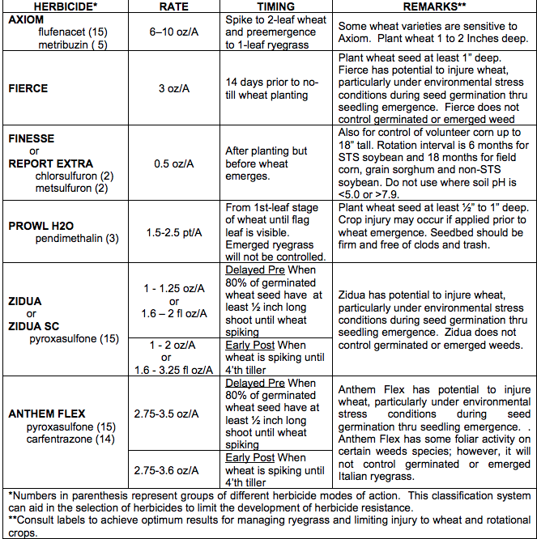

**Table from the University of Kentucky**

**Italian Rye Grass Control in Wheat**



**For more information regarding any of your farming needs, please feel free to contact the Bertie County Cooperative Extension Office at (252) 794-5317. Your questions and comments are important to us.**

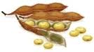

**WHEAT PLANTING DATE**

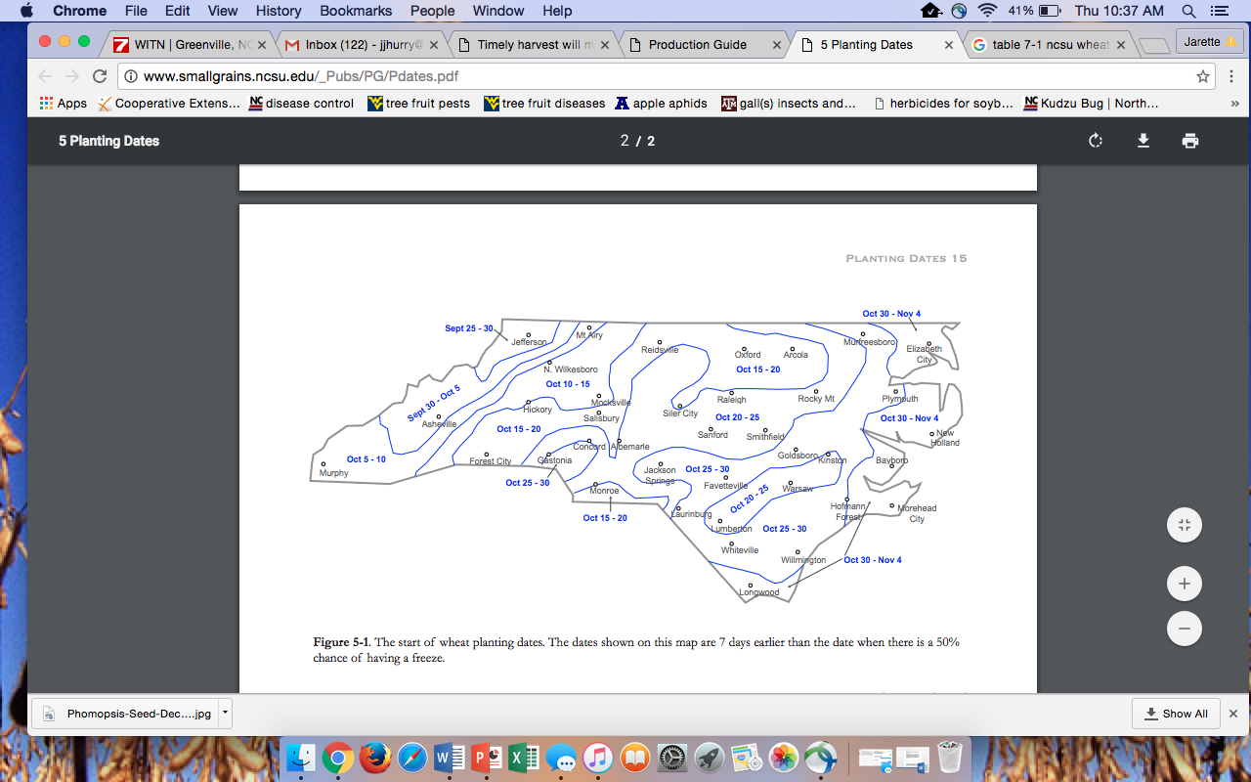

**Seeding Rates**

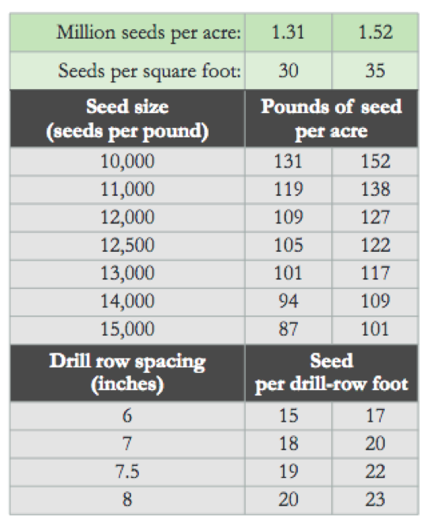

Seeding rate ranges for the state are recommended between 1.6 million and 2.1 million seeds per acre. Remember that each variety and lot may have a different number of seeds per pound. If you’re using a grain drill the range is about 21 to 28 seeds per row foot. For a broadcast situation that’s going to look like 37 to 48 seeds per square foot.

When planting on time, 15 to 30 pounds preplant N per acre are generally sufficient to promote maximum growth and tillering. This application can be very important for high yields because N stress early in the season will prevent adequate tillering. When small grains follow soybeans or peanuts, enough carryover N may be present to meet small grain fall requirements. Unfortunately, the availability of carryover N is difficult to predict and there is no method for testing for available N in the fall. In many years and locations, the N released from a previous legume crop may not be available until the following spring or even summer, which is too late to support fall tillering. Consequently unless experience with specific fields indicates otherwise, a small amount of preplant N is recommended even when following soybeans or peanuts.

**FALL PRE PLANT NITROGEN**

**WHEAT OR NO WHEAT**

**Submitted by: Billy Barrow**

We have seen an uptick in grain prices over the last 4-6 weeks which has certainly helped. Hopefully we will continue to see some strength in the markets. Even with these increases we are just barely at a point to cover the costs in most grain crops given our traditional yields.

As wheat prices increase its worth the time to look at it as an alternative to full season soybeans and corn. As you know the key to profitability in grains with the prices offered is productivity. With average yields we are just barely getting by.

Wheat and double crop soybeans offer a chance to spread production, weather and price risk. It also adds to an operation‘s cash flow. The table below offers general costs and returns on these options. The key to each of these is timeliness. Preplant weed control and fertilization on our wheat crop will pay dividends as the season progresses. Beating out the competition from weeds and grasses and setting an appropriate number of tillers are keys to a high yielding crop.

If you want to dig deeper into crop comparison check out the website below from NCSU Extension economics. <https://cals.ncsu.edu/are-extension/crops-marketing-and-logistics/grain-marketing/> Once you open it up, scroll down to Crop comparison Tool. You can customize it with your costs, yields and prices. If you need help from us deciphering all the options give us a call and we will be glad to work with you.

|  |  |  |  |  |  |
| --- | --- | --- | --- | --- | --- |
|  |  | **Soybean** | **Wheat** | **Soybean** | **Corn** |
| **2020 Comparison** |  | **Double Crop** |  | **Full Season** |  |
|  |  |  |  |  |  |
| **2021 contract price** |  | $9.30 | $5.73 | $9.30 | $3.94 |
|  |  |  |  |  |  |
| **Yield** |  | 30 | 70 | 45 | 125 |
|  |  |  |  |  |  |
| **Gross Revenue** |  | 279 | 401.1 | 418.5 | 492.5 |
|  |  |  |  |  |  |
| **Varible Expense** |  | 190 | 225 | 230 | 405 |
|  |  |  |  |  |  |
| **Fixed Expense** |  | 53.46 | 33.31 | 53.46 | 54.67 |
|  |  |  |  |  |  |
| **Returns to Land, Mgmt** |  | 35.54 | 142.79 | 135.04 | 32.83 |
| **combined Wheat/2x S/B** |  | $178.33 |  |  |  |



**NCDA & CS REMINDS USERS TO SUBMIT SOIL SAMPLES BY NOVEMBER 23RD TO AVOID**

**PEAK-SEASON FEES**

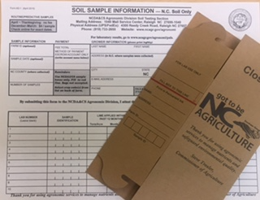

**The N.C. Department of Agriculture and Consumer Services reminds growers that soil samples submitted by November 23, 2020 will be processed free of charge.**

**Processing for soil samples arriving between NOVEMBER 27, 2020**

**and APRIL 2021 will cost $4 per sample**



****Bertie County Cooperative Extension**

**Visit us: www.bertie.ces.ncsu.edu**

**Jarette Hurry**

**Agriculture Agent**

**North Carolina Cooperative Extension**

Bertie County Center

104 Dundee St., PO Box 280

Windsor, NC 27983

**Email** – **jjhurry@ncsu.edu**

**Cell** (252) 325-3091

**Office** (252) 794-5317

**Fax** (252) 794-5375

**Visit us: www.bertie.ces.ncsu.edu**



NC State University and N.C. A&T State University commit themselves to positive action to secure equal opportunity regardless of race, color, national origin, religion, political beliefs, family and marital status, sex, age, veteran status, sexual identity, genetic information or disability. NC State, N.C. A&T, U.S. Department of Agriculture, and local governments cooperating.